**Lockers.LockedMe.com -**

**A Virtual Key for Your Repositories**

System Designed and Developed by

HEERA P

**Table of Contents**

## **1.0 Introduction**

### 1.1 Scope

### 1.2 Product Features

### 1.3 User characteristics

### 1.4 Constraints

## **2.0 Sprint Planning**

## **3.0 System Requirements**

### 3.1 Software requirements

### 3.2 Functional requirements

## **4.0 System Design**

### 4.1 Flow of the Application

### 4.2 Algorithm

## **5.0 Coding**

### 5.1 Codes

## **6.0 Conclusion**

## **7.0 Link to the GitHub repository**

## **1.0 Introduction**

### 1.1 Scope

### ‘Lockers. lockedMe’ application will help you to handle your files in an easy way. It will create a virtual repository for you to keep your files and manipulation of the files.

### 1.2 Product Features

### The major features that the application will perform: -

### Adding files to the repository.

### Deleting files from the repository.

### Searching for a specific file in the repository.

### Display all files in the repository in ascending order.

### 1.3 User characteristics

### As this is a prototyped application, the user interaction will be via a command line.

### 1.4 Constraints

### OS specification restricts to ignore the case sensitivity of the file names while adding files to the directory.

## **2.0 Sprint planning and the tasks achieved**

## This application is planned to be completed in 1 sprint. The flow given below after updating the status.

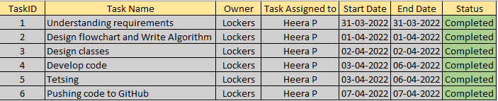

### 3.0 System Requirements

### 3.1 Software requirements

### Eclipse IDE

### jdk1.8

Core concepts used in project:

* File Handling, Sorting, Collections framework and Exception Handling

### 3.2 Functional requirements

The system should be able to perform the listed activities: -

1. Code to display the welcome screen. It should display:

* Application name and the developer details
* The details of the user interface such as options displaying the user interaction information
* Features to accept the user input to select one of the options listed

1. The first option should return the current file names in ascending order. The root directory can be either empty or contain few files or folders in it
2. The second option should return the details of the user interface such as options displaying the following:
   * Add a file to the existing directory list
     + Case sensitivity of the file names can be ignored
   * Delete a user specified file from the existing directory list
     + Add case sensitivity on the file name in order to ensure that the right file is deleted from the directory list
     + Return a message if FNF (File not found)
   * Search a user specified file from the main directory
     + Add the case sensitivity on the file name to retrieve the correct file
     + Display the result upon successful operation
     + Display the result upon unsuccessful operation
   * Option to navigate back to the main context
3. There should be a third option to close the application

## **4.0 System Design**

### 4.1 Flow chart - represents the flow of Application

### 

### 4.2 Algorithm Design

1.Create the project in Eclipse

2.Write the code for main program which will call respective functions accordingly.

* Class name: LockersMain.java
* Functions to be called - display welcome screen and main menu choosing function for display file names, switch for file manipulation functions and an exit from the program.

3.Display welcome screen and menu driven program m for choosing the required function.

* Class name: welcomeScreen.java, SelectOperation.java
* Functions which are invoked - for display welcome screen, main menu choosing function and file operation menu choosing function.

4.Create the directory if not present and show all the files in the directory in ascending order.

* Class name: Directory.java
* Functions which are invoked – create directory, display file names from the directory.

5.Write code to manipulate the files in the directory, functions like adding the files, deleting the files and search for a specified file and return to main menu.

* Class name: FileManipulation.java
* Functions which are invoked –adding a file, deleting a file, searching a file and return to main menu.

6. Pushing the code to GitHub repository.

## **5.0 Coding**

### 5.1 Codes

## Demonstrating the product capabilities, appearance, and user interactions

### LockersMain.java

**public** **class** LockersMain {

**public** **static** **void** main(String[] args) {

welcomeScreen welcomeScreen = **new** welcomeScreen();

welcomeScreen.displayWelcomeMessage("Lockers.LockedMe.com", "Heera P");

SelectOperation selectOperation=**new** SelectOperation();

selectOperation.mainMenuChoosingFunction();

}

}

### welcomeScreen.java

**package** com.lockedme.lockers;

**public** **class** welcomeScreen {

String applicationName;

String developerName;

**public** **void** displayWelcomeMessage(String applicationName, String developerName) {

System.***out***.println("\n------------Welcome to " + applicationName +"--------------");

System.***out***.println("This application was desgined and developed by "+developerName);

System.***out***.println("\n********************************************************** \n\n");

System.***out***.println("‘Lockers.lockedMe’ application will help you to handle your files in an easy way!!"+"\n"+" Please go through the actions you can perform here:-");

}

**public** **void** displayMainMenu() {

System.***out***.println("\n1. Show file names.");

System.***out***.println("2. Go for any file operations.");

System.***out***.println("3. Exit the application.\n");

System.***out***.println("----------Make your choice:----------\n");

}

**public** **void** displayFileMenu() {

System.***out***.println("\n1. Add a File");

System.***out***.println("2. Delete a File");

System.***out***.println("3. Search for a File");

System.***out***.println("4. Return to Main menu");

System.***out***.println("----------Please choose the required file operation:----------\n");

}

}

**OUTPUT**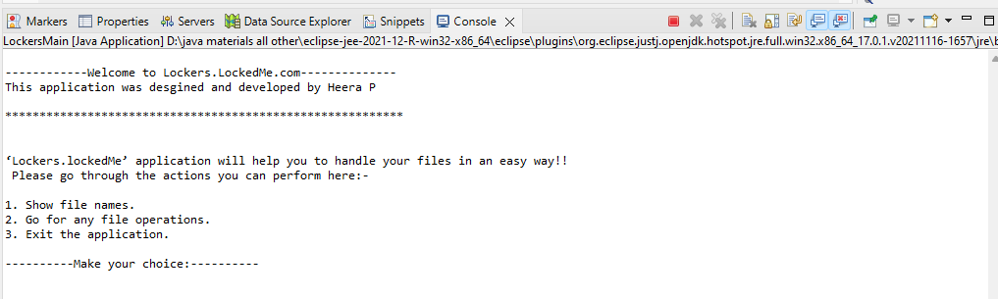

### SelectOperation.java

package com.lockedme.lockers;

import java.util.InputMismatchException;

import java.util.Scanner;

public class SelectOperation {

Directory directory = new Directory();

welcomeScreen welcomeScreen = new welcomeScreen();

private int userChoice() {

int choice= 0;

Scanner sc = new Scanner(System.in);

try {

choice = sc.nextInt();

}

catch (InputMismatchException ex) {

}

return choice;

}

//redirecting to the execution part based on user inputs

public void mainMenuChoosingFunction() {

while(true) {

welcomeScreen.displayMainMenu();

switch(userChoice()) {

case 1:

directory.showDirectoryContents();

break;

case 2:

fileMenuChoosingFunction();

break;

case 3:

System.out.println("Program exited successfully.");

System.exit(0);

break;

default:

System.out.println("Invalid choice.");

}

}

}

public void fileMenuChoosingFunction() {

FileManipulation fileManipulation=new FileManipulation();

while(true) {

welcomeScreen.displayFileMenu();

switch(userChoice()) {

case 1:

fileManipulation.addFile();

break;

case 2:

fileManipulation.deleteFile();

break;

case 3:

fileManipulation.searchFile();

break;

case 4:

mainMenuChoosingFunction();

break;

default:

System.out.println("Invalid choice.");

}

}

}

}

**OUTPUT**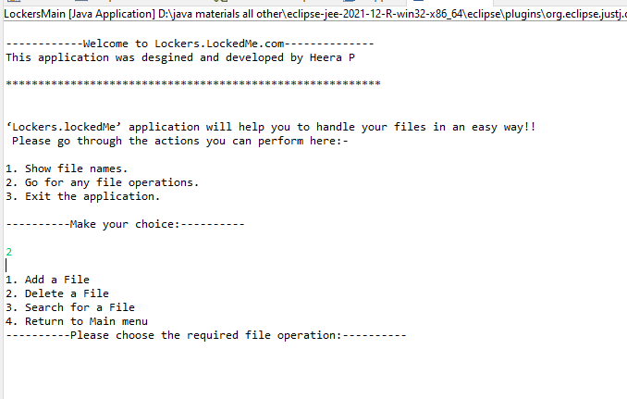

### Directory.java

**package** com.lockedme.lockers;

**import** java.io.File;

**import** java.nio.file.FileSystems;

**import** java.nio.file.Path;

**import** java.util.ArrayList;

**import** java.util.Collections;

**public** **class** Directory {

**private** ArrayList<File> files = **new** ArrayList<File>();

**public** **static** **final** String ***rootDir***="D:\\java\\Java_programs\\Phase1Project-Virtual Key for Your Repositories\\FileFolder\\";

Path path = FileSystems.*getDefault*().getPath(***rootDir***).toAbsolutePath();

**public** **static** **void** checkdirectory(String directoryName) {

File file = **new** File(directoryName);

**if** (!file.exists()) {

file.mkdirs();

}

}

**public** **void** showDirectoryContents() {

*checkdirectory*("FileFolder");

Boolean flag=getFiles().isEmpty();

**if**(flag==**false**)

{

System.***out***.println("Filenames in ascending order");

System.***out***.println("---------------------------------------");

**for** (File file : getFiles())

{

System.***out***.println(file.getName());

}

}**else** {System.***out***.println("Sorry!! Empty Directory!!");}

}

**public** ArrayList<File> getFiles() {

File filefolder= **new** File(***rootDir***);

File[] directoryFiles=filefolder.listFiles();

files.clear();

**for** (**int** i = 0; i < directoryFiles.length; i++) {

**if** (directoryFiles[i].isFile()||directoryFiles[i].isDirectory()) {

files.add(directoryFiles[i]);

}

}

Collections.*sort*(files);

**return** files;

}

}

**OUTPUT**

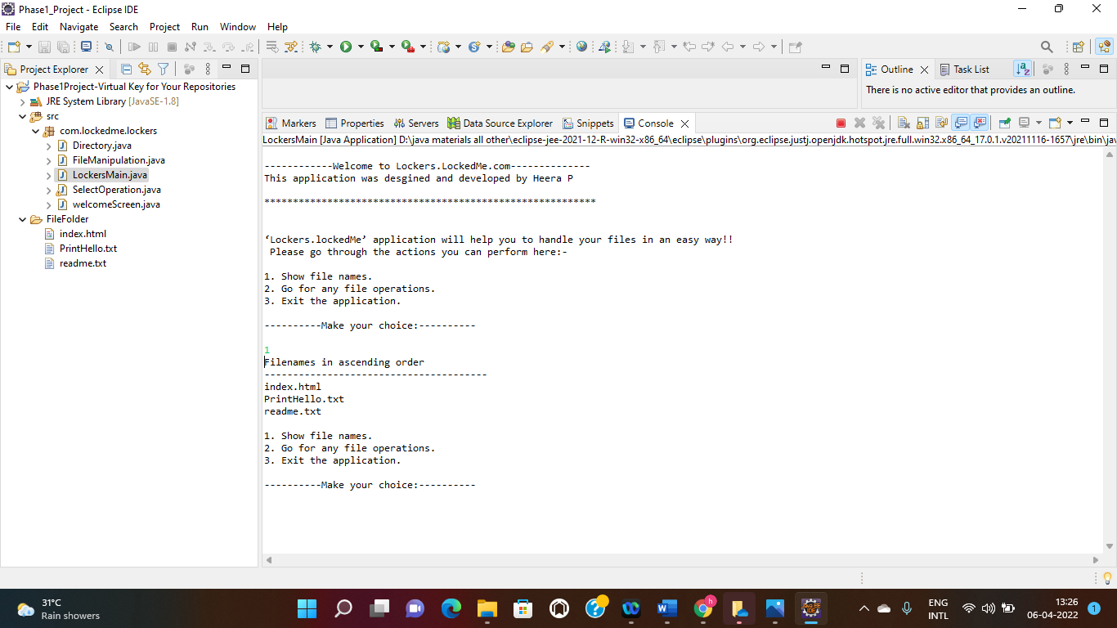

### FileManipulation.java

package com.lockedme.lockers;

import java.io.File;

import java.io.IOException;

import java.util.ArrayList;

import java.util.Scanner;

public class FileManipulation {

static Scanner sc=new Scanner(System.in);

private Directory dir = new Directory();

private Boolean searchStatus = false;

private File directory = new File(Directory.rootDir);

public String getUserInput(String operation) {

System.out.println("Please Enter the Filename to be "+operation);

String fileName = sc.nextLine();

if(fileName.isEmpty()||(fileName.startsWith(" "))) {

System.out.println("Not a valid filename. Please choose another and continue.");

return null;

}else

return fileName;

}

public void addFile() {

Directory.checkdirectory("FileFolder");

String fileName=getUserInput("added:");

try {

if(fileName!=null) {

File newfile = new File(Directory.rootDir + fileName);

if(newfile.exists()) {

System.out.println("Filename already exists!! No file created.");

}

else if(newfile.createNewFile())

{

System.out.println("You are trying to add the file named:" +"'"+fileName+"'"+" in the path:-"+Directory.rootDir);

System.out.println("File created: " + newfile.getName());

}

}

}catch (IOException e){

System.out.println("Invalid..Please try again");

}

}

public void deleteFile() {

String fileName=getUserInput("deleted:");

try {

if(fileName!=null){

if((directory.isDirectory())&&(searchForFile(fileName)==true)) {

System.out.println("You are trying to delete the file named:" +"'"+fileName+"'"+" in the path:-"+Directory.rootDir);

File newfile = new File(Directory.rootDir + fileName);

if(newfile.delete())

{

System.out.println(fileName+" Deleted successfully:");

}

}else {

System.out.println("File does not Exists!");

}

}

}catch (Exception e) {

System.out.println("Invalid..Please try again");

}

}

private Boolean searchForFile(String fileName) {

searchStatus = false;

String fileToSearch=fileName;

ArrayList<File> files=dir.getFiles();

for(int i = 0; i < files.size(); i++) {

if(files.get(i).getName().equals(fileToSearch)) {

searchStatus = true;

}

}

return searchStatus;

}

public void searchFile() {

try {

String fileName=getUserInput("searched:");

if(fileName!=null){

searchStatus=searchForFile(fileName);

if((directory.isDirectory())&&(searchForFile(fileName)==true)) {

System.out.println("File found");

}

else{System.out.println("File not found");}

}

}catch (Exception e) {

System.out.println("Invalid file name");

}

}

}

**OUTPUT**

**Adding a file:**

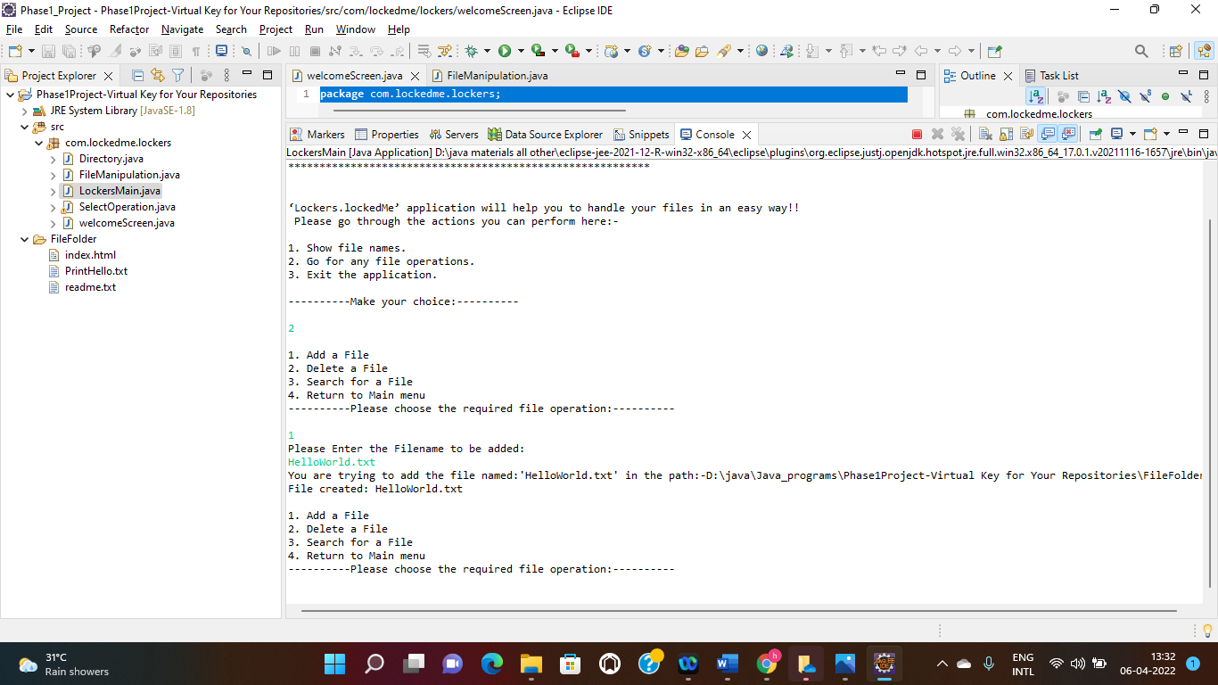

**File folder structure after adding HelloWordl.txt:**

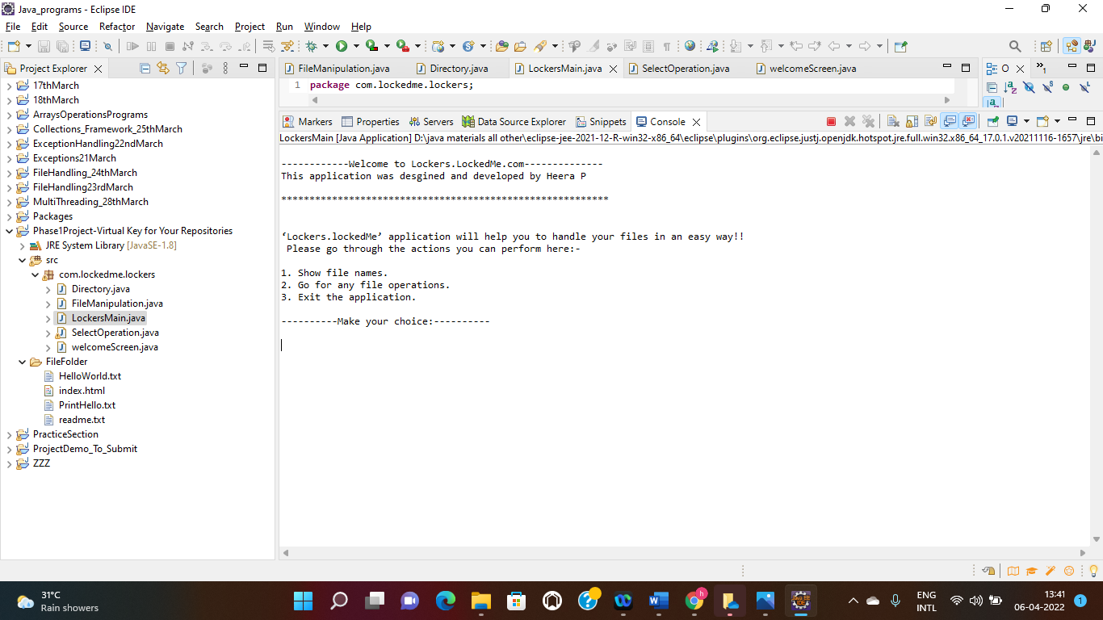

**Deleting a file:**

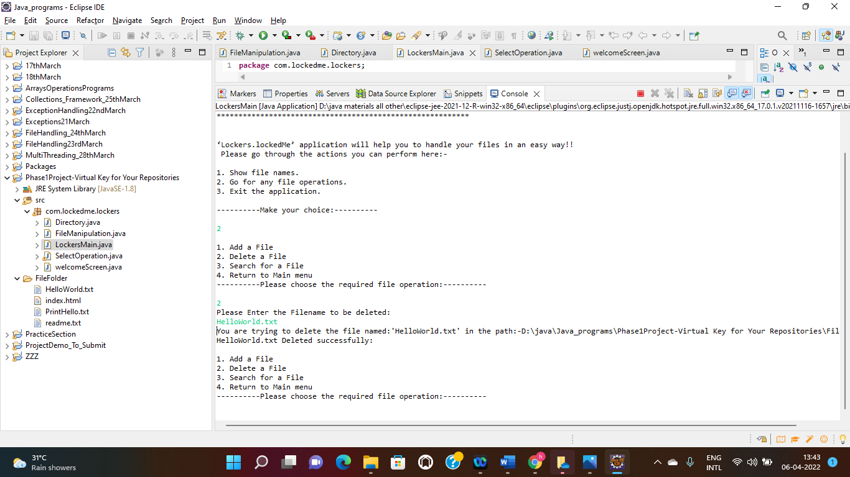

**File folder structure after deleting HelloWordl.txt:**

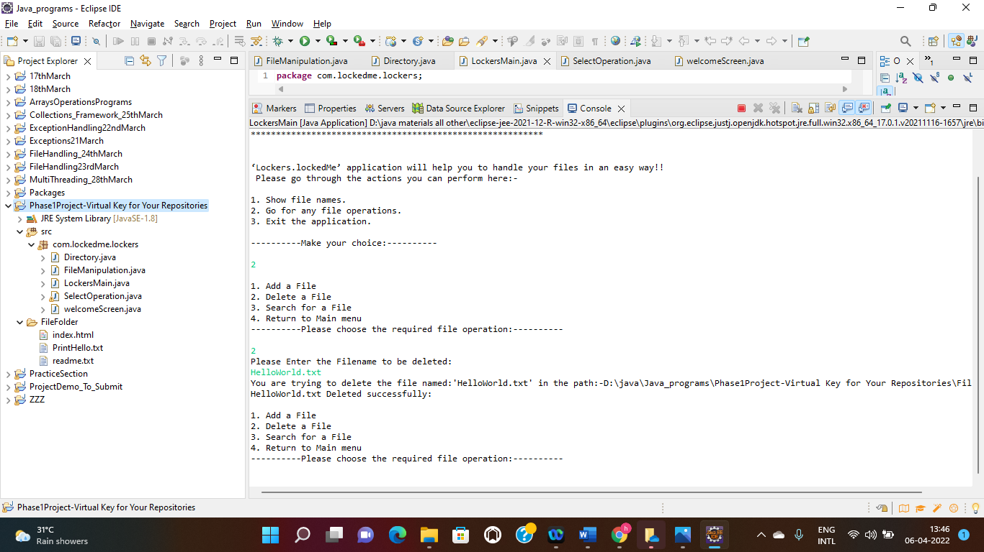

**Searching a file- File found:**

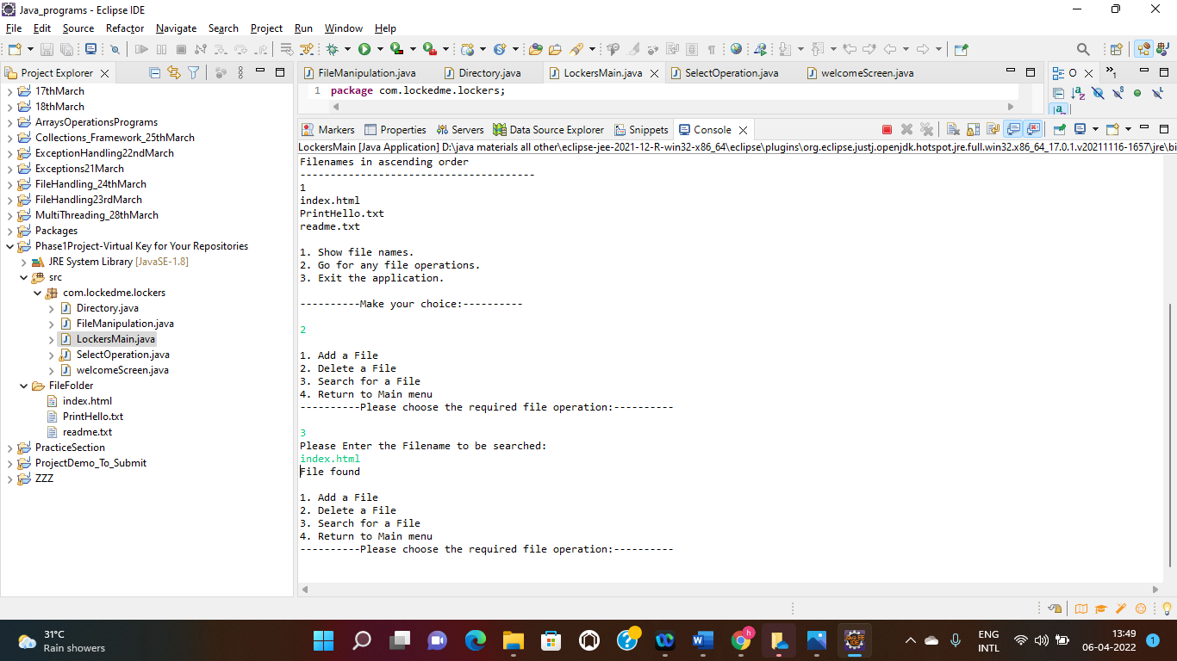

**Searching a file- File not found:**

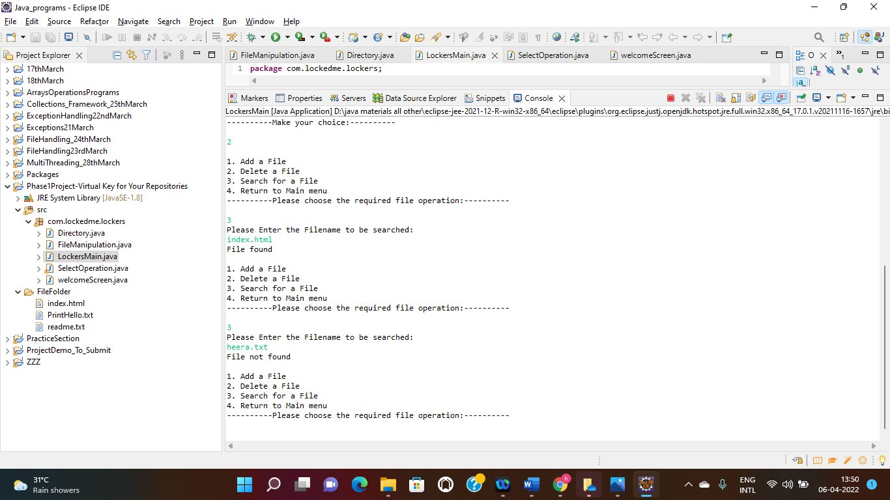

## **6.0 Conclusion**

Lockers. lockedMe’ application mainly focused to digitize your files in a very easy manner. Which will provide a virtual repository for you to keep your files and make actions on it. Unique selling points of this application is, application will not close, exit, or throw an exception if the user specifies an invalid input. Further enhancements to the application could be adding contents to the files and searching files based on a wide variety of benchmarks**.**

### 

## **7.0 Link to the GitHub repository**